IMPORTANT INFORMATION ABOUT YOUR DRINKING WATER

Camp Lester, South Detectable Levels of Per- and Polyfluoroalkyl Substances (PFAS)

Marine Corps Base (MCB) Camp Butler Environmental Affairs Branch (EAB) routinely monitors for the presence of drinking water contaminants. Department of Defense (DoD) policy issued on 11 July 2023 required testing of all DoD-owned drinking water systems for PFAS by 31 December 2023. Samples from the Camp Lester Water Treatment Plant (WTP) Finished Water Reservoir were collected on 13 December 2023 and results were received on 13 February 2024. Those results reported concentrations of PFAS as listed in Table 1 below. Lester WTP provides drinking water to residents and occupants located in Camp Lester, South only (Old Lester Housing, Lester Middle School, and additional facilities – see Figure 1). PFAS was not detected in drinking water at any other Marine Corps installation on Okinawa.

Per the Japan Environmental Governing Standards (JEGS), the regulatory policy governing drinking water at United States military installations in Japan, there is no maximum contaminant level established for PFAS. In accordance with the 11 July 2023 Department of Defense (DoD) policy, we are required to notify the public of detectable PFAS in the drinking water supplied by DoD-owned water systems. DoD policy also requires us to take action to provide alternative drinking water if the concentrations of Perfluorooctanoic acid (PFOA) and Perfluorooctanesulfonic acid (PFOS) exceed 70 parts per trillion (ppt) (also expressed as nanograms per liter (ng/L), individually or combined. The sample results are below these levels.

The health and well-being of our service members, their families, and civilian employees remains a high priority for us, and we will continue to work to protect the drinking water on the installations. We will continue to regularly sample drinking water to ensure health and maintain compliance with established standards.

**Table 1:** Camp Lester WTP Finished Water Reservoir PFAS Results

|  |  |  |  |
| --- | --- | --- | --- |
| PFAS Analyte | Abbreviation | Result  (ppt) | DoD Action Level  (ppt) |
| Perfluorooctanoic acid | PFOA | 6.5 | 70 |
| Perfluorooctanesulfonic acid | PFOS | 18 | 70 |
| PFOA + PFOS | | 25  (calculated) | 70 |
| Perfluorobutanesulfonic acid | PFBS | 3.0 | N/A |
| Perfluorobutanoic acid | PFBA | 3.9 |
| Perfluorohexanesulfonic acid | PFHxS | 15 |
| Perfluorohexanoic acid | PFHxA | 3.7 |
| Perfluoropentanoic acid | PFPeA | 2.7 |

**What are Per- and Polyfluoroalkyl substances and where do they come from?**

PFAS are a group of thousands of man-made chemicals that have been used in a variety of industrial and consumer products around the world for decades. Due to their widespread use and environmental persistence, most people have been exposed to certain PFAS. They have been used to make coatings and products that are used as oil and water repellents in carpets, clothing, paper packaging for food, and cookware. They are also contained in some aqueous film-forming foam (AFFF) used for fighting petroleum fires at airfields and for industrial fire suppression.

**What does this mean?**

Research is still ongoing to understand the mechanisms of PFAS toxicity. The risk of health effects associated with PFAS depends on exposure factors (dose, frequency, route, duration), individual factors (sensitivity and chronic disease burden), and other determinants of health. The epidemiological evidence suggests associations between increases in exposure to specific PFAS and certain health effects. For specific information about the health effects of PFAS exposure, please visit https://www.atsdr.cdc.gov/pfas/.

**Are there regulations for PFAS in drinking water?**

There are currently no federal or overseas drinking water standards for any PFAS compounds. Until these regulations are finalized, the Department of Defense issued a policy on 11 July 2023 establishing action levels requiring alternative drinking water to be provided if individual or combined concentrations of PFOA and PFOS exceed 70 ppt for DoD-owned drinking water systems worldwide. DoD installations are also required to post sampling results of detected PFAS on each installation’s public webpage and in the annual Consumer Confidence Report (accessible at https://www.mcipac.marines.mil/News-Center/Consumer-Confidence-Reports/).

**What about the EPA’s 2023 proposed regulations?[1]**

In March 2023, the EPA announced a proposed National Primary Drinking Water Regulation for six PFAS including PFOA, PFOS, PFNA, HFPO-DA (GenX Chemicals), PFHxS, and PFBS. The EPA anticipates finalizing the regulation in 2024 and water systems will have three years to comply. The DoD supports the EPA taking regulatory actions to address PFAS, including a drinking water standard that will apply to all drinking water suppliers once final. This standard is expected to be adopted into the JEGS, when finalized.

**What can I do?**

There is nothing you need to do, as there is no immediate risk to the general population. You may continue to use the water for all consumptive purposes (drinking, bathing, showering, cooking, dishwashing, and maintaining oral hygiene).

**What is being done?**

MCB Camp Butler, EAB will continue to monitor for PFAS in the treated drinking water for Camp Lester, South on a semi-annual basis as required. Additionally, MCB Camp Butler and joint service partners will continue to evaluate possible mitigation measures in accordance with DoD policy and in anticipation of the new EPA regulation.

For more information, please visit Defense.gov/pfas at <https://www.acq.osd.mil/eie/eer/ecc/pfas/index.html>, or send inquiries to EAB Drinking Water Program Manager at [mcbb.gf.envwater@usmc.mil](mailto:mcbb.gf.envwater@usmc.mil), or call 098-970-5197.

This notice is being sent to you by MCB Camp Butler Environmental Affairs Branch (EAB).

Date distributed: 22 MAR 2024

**Figure 1:** Buildings served by Camp Lester WTP

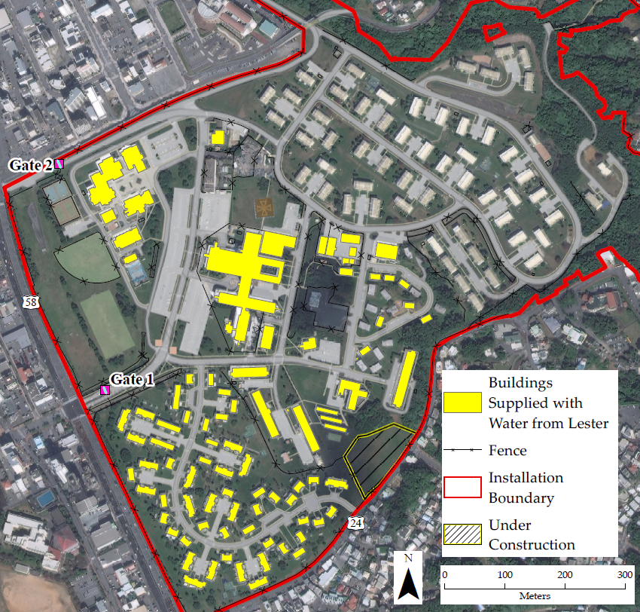

1. https://www.epa.gov/sdwa/questions-and-answers-drinking-water-health-advisories-pfoa-pfos-genx-chemicals-and-pfbs